***GPN Assignment 2 (Koo Bing En S10244655D)***

***Designer Diary -Flix Odessey***

***1st Week***

**Date: 27th June**

Before me and my teammate decides which game engine (Godot, Unity, Game Maker) to use for this project, we start brainstorming ideas about the storyline and protagonist suitable for this project. The concept we've decided to pursue is a 2D RPG, a genre that allows us to delve deep into character development and intricate storytelling. Our protagonist, Eris, is a young, gifted alchemist from the tranquil village of Elderglen. Known for her curiosity and intelligence, she's a character that's as endearing as she is prone to finding herself in a pickle. We're eager to craft her journey from a naive village girl to a world-saving heroine, a transformation that will be as challenging as it is rewarding.

Our storyline is steeped in mystery and adventure. It begins with Eris stumbling upon an ancient alchemical tome hidden in the forest, a discovery that sets the wheels of destiny in motion. The tome holds a prophecy of a cataclysmic event that threatens to obliterate the world. Eris, being the only one capable of deciphering the tome, takes it upon herself to prevent this prophecy from becoming reality. As she steps out of her village for the first time, she embarks on a journey that will introduce her to a diverse cast of characters, each with their own stories to tell and lessons to impart. We've brainstormed a series of challenges that will test Eris's intelligence, courage, and moral compass, pushing her to the limits of her alchemical abilities. We're thrilled about the potential this game holds and can't wait to bring our vision to life.

***2nd Week***

**Date: 03th July**

After some findings and research done, we found that 2D RPG game was too challenging with the amount of time we’ve given in fact it was too ambitious. Therefore, we have finalized our idea and decided to make a 2D platformer game with the use of Game Maker engine as it is simpler and easier to use. As we already have an image in mind of how the platform and theme should look like we started to find the desired game assets like image, tiles, background, and characters that we could possibly use or apply in the game.

The overall game idea/storyline for 2D platformer game:  
**Protagonist:**

A young and adventurous creature named "Flix", is chosen by the ancient spirits to restore balance. Flix must journey through each realm, overcoming increasingly challenging platform levels, to retrieve the pieces of the Orb and restore harmony.

**Storyline:**

Our game could be set in a world where each realm is governed by a unique element (fire, water, earth, air, etc.). The harmony of these realms is maintained by a mystical artifact known as the "Elemental Orb". However, an evil sorcerer has the Orb, causing chaos and imbalance among the realms. Each piece of the Orb has landed in a different realm, altering its nature and making it hostile.

**Gameplay Elements:**

Each realm could have unique gameplay mechanics related to its element. For example, the earth realm could have destructible terrain, the water realm could have underwater physics, and the air realm could have wind currents affecting movement. This would keep the gameplay fresh and engaging, as players would need to adapt to the changing mechanics.

As the game progresses, the levels would become more challenging, reflecting Flix's growing skills and maturity. The final level could be a confrontation with the sorcerer, where Flix must use all the skills he's learned to defeat him and restore the Orb.

Remember, it's crucial to playtest and iterate on your game design to ensure it's fun and engaging. Listen to player feedback and be willing to make changes based on their input. This will help you create a game that players will love and keep coming back to.

**Date: 05th July**

Before we step into shaping the mechanics of the game or writing codes for the character to move and how the enemy should be attacking, I’ve done some research about ways to use Game Maker for platformer game. Besides, just when I thought Game Maker it easy to use and how the character can be moving by writing a few lines of codes when watching tutorial videos online about Game Maker, it was in fact a little more complicated when I started shaping out my ground/tiles throughout the map horizontally. We’ve found some assets online that could be used in our game which include assets like characters, tiles, enemies, and backgrounds. Firstly, I imported the tiles that I wanted to use as a sprite into Game Maker and adjust its size, moreover I imported that particular sprite as a Tile Sets whereby the tile image is being cut into small pieces with the size of 16 by 16 for me to easily lay out on the room where players will be playing. Furthermore, I created a tile layer inside the room and started to design the ground of the game by placing the tile set that I have previously cut around the room. The width for level 1 room is around 3500px which was quite a short distance for a platformer game, as we are creating few different levels, we wanted the first level to be a little shorter for players to get use to it and when level start increasing after one has completed the distance will be longer as well as harder for players to experience.

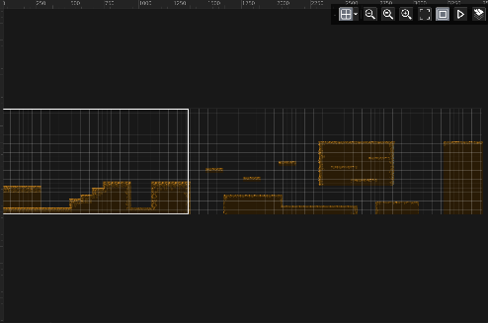

**Date: 07th July**

After finishing a brief layout of the ground for the game. We started to implement the character sprite. As we’ve previously found some assets for the character as well, and I imported it as a sprite into the game. Firstly, after importing a picture of few movements of character as sprite, I converted the image into frames and trim all frames to separate the image to each different movement. Furthermore, I imported the sprite that I edited as an object and drag into the room. Not to mention, I really enjoy and like how the game is making progress as we started implementing a little by little!

**Date: 08th July**

As after we have setup the character sprite, we started to make the background. After comparing different types and kinds of backgrounds theme and design we decided to choose forest theme for our level 1 game and the type for the background is GIF instead of pictures as it moves around as a result add a little extra visual aesthetics to the gameplay experience. Now the room of the game looks pretty well setup with the implementation of the character sprite, the ground, and the background. However, due to our GIF size that can’t really fit the size of the room as the room is horizontally longer than the GIF, we are working on to allow the background to move with the character instead of duplicating the background or stretching the background GIF that will destroy the appearance of the background.

***3rd Week***

**Date: 10th July**

Character movement & attack skills was nothing easier than any previous stuff that we have implemented so far. This was something new for us and it required some logic thinking, but we accepted the challenge! For the character movement, we have an idle (default movement) sprite for it which is the animation it will play when the character stand on the ground of the game and do nothing and it is only called inside an ‘else’ statement when the character is not doing other stuff. Moreover, we have a running movement for the character, its basically a right and left movement whereby for the code we check when the character is on the ground and keyboard checks the key ‘D’ or key ‘right’ it will move right and same for the left movement then the character will start movement with the animation of running. Not to mention, we have also implemented down (crouch) and dash movement for the character to enhance the gameplay. Furthermore, for the attack skills of the character, we implemented 4 kinds of attack, and the mechanics was quite similar for the movement where each of the attack is being called inside an ‘else if’ statement. When the character press on specific key it will call the attack sprite with different image speed for different attacks. Now that the character is moving and attacking around the room, and we can’t wait to progress the game and see what kind of interesting stuff we are going to face!

**

**Date: 11th July**

For now, as we progress through the game it was more about the logic. We implemented the gravity mechanics whereby it allows the character to stay on the ground and to check if the character is on the ground. It wasn’t that challenging than I thought it was, firstly I created a variable in the create event as gravity = 0.4 which is the strength of the gravity and onGround = false to check if the character is currently on the ground. On the same day, we also implemented the double jump mechanics for the character to further enhance the gameplay as I think if there’s only a default jump it wouldn’t be that much fun for the character and with double jump mechanics it allows us to increase the level of difficulty to the game tiles whether to be higher or further. As for double jump mechanics, it requires to create variables of remainingJumps = maxJumps; and maxJumps = 2; so that it sets a maximum jump to the character and not let the character jump for more than two times (triple jump).

**Date: 15th July**

Now with the basic setup of the character movement and the room setup, its time for the implementation of the enemy and enemy setup across the room. Similarly like the character, I imported the enemy sprite that I’ve got as the assets and converted them to frames with several frames with different kinds of movements. Then, I make them as an object and place them across the room in specific places. For current state the character is still able to walk pass the enemy with no damage apply on the character as I haven’t added damage and attack mechanics on both the enemy and the character. After some researching and study done, firstly I add some code for the character step event so that when my character touches the enemy it decreases one HP and if the HP equals to 0 the character will spawn at the respawn spot and the hp will reset to 6 which is the default HP that the character was given. It was actually fun seeing the damage mechanics working as it wasn’t applying at first at the first few trying of the code but after some modifications of the logic it was able to damage the character.

***4th Week***

**Date: 18th July**

As we design the tiles/ground across the room we thought of making a river/water features across the room between the grounds to add a little spice to the gameplay. The logic and mechanics were simple and clear where firstly we imported the sprite of a water and make it to an object and further place it in the room. Now that the water is just a normal object and doesn’t apply any effect when the character fell into it. Therefore, we create a ‘Danger Zone’ object to place on top of the water object and add simple code for it whereby when the character touches the danger zone it applies damaging and reduces the character HP by 1. Not to mention, we’ve made the ‘Danger Zone’ object invisible so that player can’t see it but instead just able to see the river. Soon after when everything is being set across the room, I found that when player fell into the river it applies a instant die effect where the player straight away died. But we couldn’t really solve the issue after a long time we found that it’s the cooldown effect issues that causes the character to instant die, therefore we’ve implemented a cooldown damage features for the character so that the character won’t die instantly. The cooldown mechanics is pretty simple firstly I create variables for damage cooldown to equal to 0 and set the cooldown time to 2 seconds as in Game Maker 60 frames is equal to 1 second so I specify in the code as 120 which is equal to 2 seconds in Game Maker. Then, I apply the code in my character step event so that the character won’t instant die now. After a few playtest, the code is working correctly and the game seems to be more logical.

**Date: 20th July**

Previously we’ve implemented that when the character touches the enemy it applies damage to the character, but the character wasn’t able to attack the enemy. So, we added some code for the character step event so that the character is able to hit the enemy. It was indeed at little more complex than I thought, we firstly made it when the character sprite touches the enemy it applies damage to the enemy, but this wasn’t how it supposed to be because if it was this case even when the character body touches the enemy the enemy still reduces HP. Instead, we implemented a hitbox for the character, we create a hitbox sprite that is similar to the position of the character’s sword and make the hitbox into a object and apply some mechanics so the hitbox in the character step event so that the enemy are only being attack when they are touched by the hitbox itself which is located in the enemy sword and we’ve made the hitbox object invisible so that player are not able to see it. It wasn’t easy at all for this attack mechanics as we found problems along the way that we required to create an offset for the hitbox so that when the character turn in different sides it follows to either the left or right side.

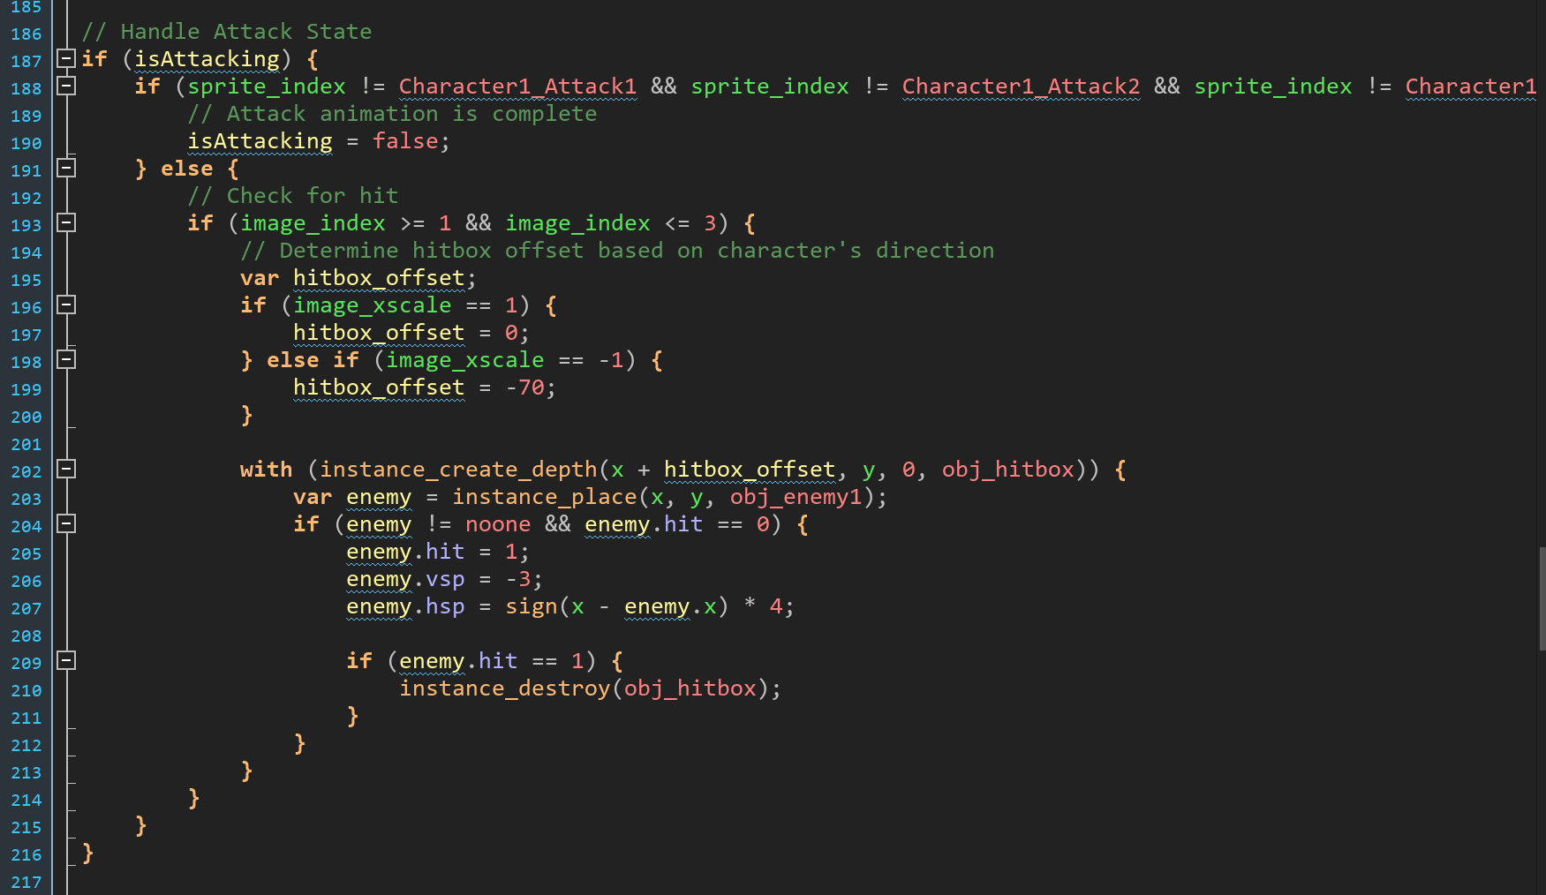

***5th Week***  
**Date: 24th July**

In addition to adding more enemy sprites with different HP systems, we also focused on enhancing the game's difficulty and overall interest. To achieve this, we incorporated a variety of enemy types, each with their own unique behaviours and attack patterns. Some of these enemy sprites were in the form of GIFs, which we sourced from Pinterest.com. These animated sprites added a dynamic element to the game, making the enemies feel more alive and engaging. For other enemy sprites that were static images, we took the time to manually convert them into individual frames, allowing them to move and interact within the game world. This attention to detail in animating the enemies not only added visual appeal but also contributed to the overall challenge and immersion of the platformer experience.

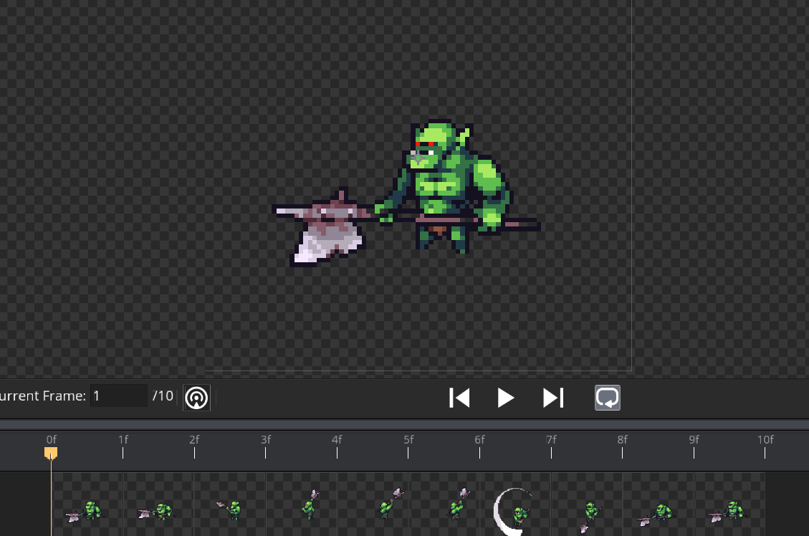  
  
**Date: 25th July**

To enhance the atmosphere and immersion of Room Level 1, we decided to incorporate background music into the gameplay experience. Our first step was to import a suitable music track in MP3 format into the game. We then created a sound object within the game engine, allowing us to manipulate and control the playback of the music. By dragging this sound object into Room Level 1, we ensured that the music would automatically start playing as soon as the player entered the room. This added a layer of audio stimulation that complemented the visuals and gameplay, setting the tone and enhancing the overall mood of the level. We carefully selected a music track that matched the theme and ambiance of Room Level 1, ensuring that it would engage players and contribute to their enjoyment of the game.

**Date: 26th July**

My teammates and I have been working on implementing an exciting knockback effect for the character itself when being hit by the enemy. We wanted to ensure that when our character object collides with the enemy object, it creates a dynamic and immersive experience for the players. To accomplish this, we carefully designed the knockback effect to give the character a sense of weight and momentum. When the character is hit, we apply a force in the opposite direction of the enemy's attack, causing the character to be pushed back. This not only visually communicates the impact but also adds a layer of challenge as players need to adjust their movement and timing to avoid further obstacles or hazards. Additionally, we made sure to balance the knockback effect to maintain a fair and enjoyable gameplay experience. We considered factors such as the character's health, enemy strength, and level design to ensure that the knockback effect doesn't become frustrating or overwhelming for players. It's important to strike a balance between challenge and accessibility to keep players engaged and motivated to overcome obstacles. After a few playtesting with the mechanics that we’ve implemented, the knockback effect not only prevents the character from simply passing through enemies but also adds a thrilling and immersive element to the gameplay.  
  
**Date: 29th July**

After adding a background sound in our game, we’ve decided to add some sound effect for our character attack also. Which is pretty simple for this mechanics to be implemented in the current state, as we’ve already got the steps required to implement the sound effect. In fact, it wasn’t by dragging the object sound into the room but instead call the sound that we’ve imported in the Game Maker In the attack state of the character step event. We’ve found multiple different sound effects for different kinds of attack so that player won’t be only hearing the same sound all the time. We didn’t really encounter any problems when implementing this as it was very straight forward. However, some of the sound effect we’ve found wasn’t that suitable with our game theme so we have to try for several times to find the best sound that could perfectly suit our game environment. Some of the sound effect was in fact a bit annoying when the we playtesting the game.

**

***6th Week***

**Date: 31st July**

As we progress through our game, we slowly realised that we don’t have some kind of home page or so call start up menu for our game whereby when we run the game it straight takes the player to the room level 1. Therefore, we’ve made a startup room which is a different room from all the levels and make it to the primary before the game starts up. We’ve found a pixel GIF background that suits our game theme and decided to put that as our menu background. Besides, we’ve also created a few buttons for the menu like play, options, stats, and exits. When the player chooses play button it will bring them to room level 1 of the game. Something similar from the previous, is that we’ve added a sound effect for the buttons, when the player choosing the buttons from the directly up and down it applies some sound effect to it and when the player clicks on the specific buttons it applies another sound effect as a sign of button being clicked. In order to achieve all these, we firstly created a menu object and create a draw event to draw all the text and for create event is to create all the variables like ‘play’ and ‘options’ and so on, and for the step events is where we code how the buttons should work.

Some of the issues we encountered during this stage is that, as we have a triangle pointer located on the left side of the menu navigation when we press up and down it doesn’t really follow downwards and upwards at the same time it tends to continuously goes downwards even after the options ends, and in order to solve that issue we found that its at the draw events where the buttons wasn’t being drawn at the correct places in fact it was outside the room therefore we have to ensures that the cursor does not move beyond the valid range of menu options. We implemented a clamp function which is used to restrict the value of selected within a specified range. In this case, the range is from 0 to array_length_1d(menu) - 1, where array_length_1d(menu) represents the number of options in the menu. By clamping the value, the cursor stays within the valid range, preventing it from going out of bounds.

**Date: 2nd Aug**

We chose a few different fonts before we’ve chosen our final fonts which is the (VCRosdNEUE) fonts that we’ve imported into the Game Maker from online. As it is a pixel kind font it perfectly suits out pixel theme of the game. Further the day, we also made a hit flash effect for the character and enemy whereby when either the enemy or the character is being hit or damage it applies the hit flash effect to both of them so that the character or the enemy blinks within a few seconds to notify the players that the character it being damage and the enemy is being hit other than just seeing the hp going down. When we first started to create this effect, it didn’t work as how we wanted as the character keep blinking forever when being hit once and we realised it’s the code logic that make it that way. Soon after, we only found out that there’s a build in shaders effect in Game Maker that we only need to create a shader in the Game Maker and call the function when the character it being hit. Therefore, it is so much easier than coding out ourselves. Not to mention, the function is being called in the character draw event as well as the enemy draw event so that every time when either of them is being hit or damage it called the function and apply the hit flash effect to the object.

***7th Week***

**Date: 4th Aug**

We added a lot more environment sprite to Game Maker and assembled them across the room to further enhance the aesthetic of the game. From intricately designed statues that add a touch of grandeur to the scene, to flickering fireplaces that infuse warmth and ambiance, each sprite has been thoughtfully chosen to contribute to the overall aesthetic. Additionally, we have included flags that flutter in the virtual breeze, lending a sense of movement and life to the surroundings. Even the smallest details, such as carefully positioned stones, have been added to enhance the realism and depth of our game world.

**  
  
Date: 6th Aug**

We continued our journey by moving to Room Level 2 after successfully setting up Room Level 1. This new level takes on a captivating winter theme, offering a distinct visual design from the previous level. We imported different tile sets and assets to create a unique atmosphere that immerses players in a winter wonderland.

As we delved into designing Room Level 2, we encountered new challenges and increased difficulty. Since we wanted to maintain the authenticity of our game, we decided to create all the designs ourselves, including the layout of the ground and tiles. This decision proved to be both rewarding and demanding. We spent a considerable amount of time brainstorming and refining the layout to enhance the overall gameplay experience.

Although we had gathered valuable knowledge from designing the layout in Level 1, Level 2 presented its own set of considerations. We had to think creatively to come up with fresh and engaging layouts that would keep players on their toes. One notable difference was the horizontal length of the room, which was intentionally longer than the previous level. This adjustment added an extra layer of challenge and complexity to the game.

To further elevate the difficulty and introduce new gameplay mechanics, we incorporated steep hills into Level 2. These hills were absent in Level 1, providing players with a new obstacle to overcome. By carefully crafting the placement and design of these elements, we aimed to create a sense of progression and excitement as players advanced through the game.

Designing Room Level 2 was a labour of love that required meticulous attention to detail and a deep understanding of player engagement. We strived to create a level that not only showcased our creativity and innovation but also provided an immersive and enjoyable experience for players.

**Date: 7th Aug**  
In our latest update, we've made some exciting changes to the backgrounds in both Level 1 and Level 2 of our game. Instead of using static images or GIFs, we decided to implement a parallax background effect that we found on the itch.io online asset store. This new pixel parallax background adds depth and immersion to the game environment.

To achieve this effect, we imported 5-6 different layers of the background as sprites into Game Maker. We then created a parallax object and wrote a code in the step event of the object to control the camera view. By dragging the parallax object into both rooms, we were able to create a parallax effect where the background moves at a different speed than the character. This means that when the character moves horizontally, the background also moves, creating a dynamic and visually engaging experience for the players.

The use of parallax backgrounds not only adds visual interest but also enhances the overall gameplay experience. It creates a sense of depth and movement, making the game world feel more alive and immersive. Players will now feel like they are truly exploring different environments as they progress through the levels.

We believe that these changes will greatly enhance the player's engagement and enjoyment of the game. The attention to detail in implementing the parallax effect demonstrates our commitment to creating a high-quality gaming experience. We are excited to see how players respond to these new backgrounds and look forward to their feedback during playtesting.

One particular problem we faced was the background not following correctly. After some investigation, we discovered that the issue stemmed from incorrectly calling the layer_get_id function in the parallax object's step event.

**Date: 9th Aug**

We are thrilled that we have successfully implemented a teleport system that allows players to seamlessly transition from Level 1 to Level 2 of the room after completing Level 1. To achieve this, we began by importing a teleport door sprite and transforming it into an object. We strategically placed this object in both rooms to ensure a smooth transition. When the player's character touches the teleport object, we have incorporated a collision event with the character in obj_teleport. This event triggers the mechanics room_goto(Level2), enabling the character to effortlessly move to Room 2. This teleportation mechanic adds a dynamic element to the gameplay experience, enhancing immersion and providing a sense of progression.

**Date: 10th Aug**

As for today, we've made some fantastic additions to our game's audio design! We've implemented sound effects for character damage, creating an immersive experience that enhances the impact of each hit. Additionally, we've added a subtle jumping sound that adds a touch of excitement to the game. We carefully balanced the volume of the jumping sound to ensure it doesn't overpower the overall experience, but still adds that extra layer of fun. These new audio elements truly spice up the gameplay, making it even more engaging and enjoyable for players!

***8th Week***  
**Date: 11th Aug**

We have introduced new enemy sprites to enhance the player's experience. These new enemies have a distinct appearance from the ones in level 1, signalling to the player that the game is becoming more challenging. We have also made some adjustments to their abilities, such as having enemies that can blow out fireballs with a longer attack distance. This not only adds difficulty but also makes the gameplay more interesting and engaging. Additionally, we have strategically placed more enemies in multiple locations throughout the level, creating a dynamic and unpredictable environment. These changes aim to keep players on their toes and provide a fresh and exciting gameplay experience.

**Date: 12th Aug**

In this stage where it comes to the end of the implementation of the complete game we’ve decide to add a interesting mechanic involving coins and gems. These valuable collectibles not only add an element of reward and satisfaction for players, but they also serve a crucial purpose in enhancing the gameplay experience. By collecting 15 coins or gems, players will now receive a significant boost to their character's health, gaining 1HP. This mechanic adds a strategic layer to the game, as players must decide whether to prioritize collecting coins in level 1 or gems in level 2 to maximize their character's survivability. To further enhance the immersion, we have also implemented sound effects for the coins and gems, making the collection process even more satisfying. Additionally, we have carefully designed the placement of these collectibles, ensuring that areas with a higher concentration of enemies offer more opportunities for players to gather coins and gems. This creates a dynamic and engaging gameplay experience, where players must navigate challenging enemy encounters while keeping an eye out for valuable rewards.  
  
**Date: 13th Aug**

In the final stages of our game development journey, we focused on implementing a game over system that adds a satisfying conclusion to our levels. When the player reaches the end of the levels, we have designed the game to display a "Game Over" message, followed by a celebratory cheer to acknowledge the player's victory. This system not only provides closure to the gameplay experience but also adds a sense of accomplishment and reward for the player's efforts. By incorporating this feature, we aim to create a memorable and engaging experience that leaves players feeling fulfilled and motivated to replay the game.

***9th Week***

**Date: 14th Aug**

After presenting our prototype game in class today, we eagerly gathered feedback from our fellow students, friends, and our teacher. The valuable insights we received have opened our eyes to exciting possibilities for further enhancing our game. One common suggestion was the inclusion of a pause feature, allowing players to take a breather or attend to real-life interruptions without losing progress. This mechanic would not only improve the overall user experience but also add a layer of convenience and accessibility. Additionally, we received enthusiastic feedback about expanding the game with more levels. This feedback has inspired us to dive deeper into level design, crafting new challenges and experiences for players to immerse themselves in. By incorporating these suggestions, we aim to create a game that not only captivates players with its mechanics but also provides a seamless and engaging experience from start to finish. We are excited to embark on this next phase continuing of development even after the assignment, fuelled by the valuable feedback we received during our presentation.

**Date: 16th Aug**

With the previous feedback that we’ve gathered we finally work on the pause feature that allow player to pause in the middle of the game session. Both allow the players to have a better experience of the game and the logic of the game.   
  
**Date: 18th Aug**

In our ongoing quest to create an engaging and diverse gameplay experience, we have dedicated our efforts to implementing more levels with unique themes and environments in our game. Drawing inspiration from various sources, we have meticulously crafted new levels that transport players to captivating worlds filled with wonder and excitement. Each level showcases a distinct theme, ranging from lush forests to treacherous caves, and from futuristic cities to ancient ruins. To further enrich these environments, we have introduced a plethora of new environment sprites, including flora, fauna, architectural elements, and atmospheric effects. These additions not only enhance the visual appeal of our game but also contribute to the immersive storytelling experience.

Moreover, we have taken our friends feedback into account and introduced additional difficulties to cater to a wider range of skill levels. By carefully balancing the challenges and rewards, we aim to provide a satisfying progression curve that keeps players engaged and motivated. Whether players are seeking a casual experience or a more intense and demanding gameplay session, our game now offers options to accommodate their preferences.

By expanding our game with more levels, diverse themes, new environment sprites, and additional difficulties, we are confident that we are creating an experience that will captivate players and keep them coming back for more. We are excited to see how these new additions elevate the overall gameplay and immerse players in a world of endless possibilities.

**Date: 19th Aug**

As we approach the final phase of development following the completion of our assignment, we have made an exciting decision to add a new feature that we are still working on that will greatly enhance player customization and immersion. We have decided to implement two distinct character options for players to choose from: a female character and a male character. By offering this choice, we aim to provide players with the opportunity to select a character that aligns with their own preferences and allows them to fully immerse themselves in the game.

The inclusion of both female and male characters not only adds a new layer of variety to our game but also promotes inclusivity and representation. We believe that players should have the freedom to choose a character that resonates with them, regardless of their gender identity. This decision allows us to cater to a wider audience and create a more inclusive gaming experience.

